A SEMINAR REPORT

On
AUTO CHARGING SOLAR GRINDING MACHINE
Submitted to

MALLA REDDY ENGINEERING COLLEGE
In partial fulfilment of the requirements for the award of the degree of

BACHELOR OF TECHNOLOGY
In

MECHANICAL ENGINEERING

By

M. KESHAV NAIK
20J45A0347

Under the Guidance of

Mrs. B.Charitha

(Assistant professor, Mechanical)



MECHANICAL ENGINEERING
MALLA REDDY ENGINEERING COLLEGE
(An UGC Autonomous Institution, Approved by AICTE, New Delhi & Affiliated to JNTUH,
Hyderabad).
Maisammaguda(H), Medchal - Malkajgiri District, Secunderabad, Telangana State – 500100,
www.mrec.ac.in

APRIL – 2023


MALLA REDDY ENGINEERING COLLEGE

(An UGC Autonomous Institution, Approved by AICTE, New Delhi & Affiliated to JNTUH, Hyderabad).
Maisammaguda(H), Medchal - Malkajgiri District, Secunderabad, Telangana State – 500100,
www.mrec.ac.in

MECHANICAL ENGINEERING



CERTIFICATE
Certified that seminar work entitled “AUTO CHARGING SOLAR GRINDING MACHINE” is a Bonafide work carried out in the eighth semester by “M. KESHAV NAIK” in partial fulfilment for the award Bachelor of Technology in MECHANICAL ENGINEERING from Malla Reddy Engineering College, during the academic year 2020 – 2023.
I wish her/ him success in all future endeavors.

Seminar Coordinator  Mrs. B.Charitha  Assistant professor | Internal Examiner  Mrs. B.Charitha  Assistant professor | Head of Department  Dr. A. RAVEENDRA  Professor & HOD

Place: Maisammaguda
Date: 03-04-2023

ACKNOWLEDGEMENT

We express our immense thanks to our Management and to our Principal MREC(A) Dr. A. Ramaswami Reddy, for his enthusiastic encouragement and for providing us ample facilities to execute the project work.

We would like to thank Dr. A. RAVEENDRA Professor & HOD, for providing the freedom to use all the facilities available in the department, for successful completion of project.

We sincerely acknowledge the Our guide Mrs. B. Charitha, Assistant Professor Department of Mechanical Engineering for her valuable guidance and encouragement to complete the project in a successful manner.

We sincerely thank all the Staff of the Department, for their timely suggestions, healthy criticism and motivation during the course of my project work.

Finally, we thank from the bottom of our hearts our loving parents and esteemed staff, who stood for us satisfying all our needs directly and indirectly in our endeavor.

M. KESHAV NAIK
MECHANICAL ENGINEERING
Roll. No: -20J45A0347

ABSTRACT

The Machine we designed and fabricated is used for grinding any shape of object like Circular, Rectangular, and Polygon. In our project grinding machine is used to grinding the different types of material. The grinding machine is rotated by the single-phase induction motor. Hence our project namely solar powered auto charging grinding machine is a Special type of Machine. According to the type of material to be grind, the grinding tool can be changed.
This project gives details of grinding various shapes and sizes of components. This machine can be widely applied in almost all type of industries. By varying the pulley sizes, I can get a high-end speed of over 10,000 rpm if needed. The only change I would make is to have a totally enclosed motor to keep out the grit.

Signature of the Student

Name: M. KESHAV NAIK
Roll. No: 20J45A0347
Semester: IV-II
Branch: MECHANICAL ENGINEERING
Date: 03-04-2023

TABLE OF CONTENTS

Chapter  No. |  | Description | Page  No.
 | ABSTRACT |  | iv
 | TABLE OF CONTENTS |  | v
 | LIST OF FIGURES |  | vii
 | LIST OF TABLES |  | viii
1 | INTRODUCTION |  | 1
 | 1.1 | Grinding Process | 2
 | 1.2 | Properties | 2
2 | THE TAGUCHI SYSTEM OF QUALITY ENGINEERING |  | 4
3 | CONSTRUCTION OF A GRINDING WHEEL |  | 5
 | 3.1 | Bonding materials | 5
 | 3.2 | Types of grinding Wheels | 6
 | 3.3 | According to Wheel Grade | 6
 | 3.4 | Wheel Forms | 7
 | 3.5 | Structure | 8
 | 3.6 | Bond | 8
 | 3.7 | Different types of Bonds | 8
4 | SURFACE GRINDING OPERATIONS |  | 10
5 | GENERAL SAFETY |  | 11
6 | GRINDING WHEEL OPERATING PROCEDURES |  | 11
7 | NOMENCLATURE OF GRINDING WHEEL |  | 12
8 | ANALYSIS OF GRINDING WHEEL WITH DIFFERENT SPEED |  | 13
9 | PARAMETERS OF GRINDING OPERATION |  | 13
9.1 | Cutting Speed |  | 14
9.2 | Feed rate |  | 14
9.3 | Depth of Cut |  | 15
10 | GRINDING FLUIDS |  | 15
11 | DEFECTS AND REMEDIES IN GRINDING |  | 16
12 | BALANCING OF GRINDING WHEEL |  | 18
13 | BLOCK DIAGRAM DESCRIPTION |  | 21
14 | WORKING PRINCIPLE |  | 25
15 | ADVANTAGES |  | 27
16 | DISADVANTAGES |  | 27
17 | APPLICATIONS |  | 27
18 | CONCLUSION |  | 28
19 | SCOPE FOR FUTURE WORK |  | 28
20 | REFERENCES |  | 28

LIST OF FIGURES

FIGURE NO. | TITLE | PAGE NO.
1 | Cutting principles and main variables of a Surface | 1
2 | Standard Grinding Wheel Shapes | 6
3 | Different Shapes of Grinding Wheel | 7
4 | Schematic Arrangement of stick dressing | 11
5 | Standard Marking system Chart | 12
6 | Dressing of Grinding Wheel | 17
7 | Truing of Grinding Wheel | 18
8 | Balancing of Grinding Wheel | 19
9 | Block Diagram of Grinding Wheel | 20
10 | Principle of Grinding | 25
11 | Block Diagram | 26

LIST OF TABLES

TABLE NO. | TITLE | PAGE NO.
1 | Type of Grinding according to type of workpiece, Bond and Cutting Speed | 15
2 | Influence of operating parameters on grinding wheel | 19

Chapter-1

Introduction

Our project is design and fabrication of auto charging grinding machine. It is used to grind the machining surfaces to super Finish and accuracy. The principal parts of this attachment are main body, motor with pulley, bearings, rope pulley and alternator etc. Manufacturing is derived from the Latin word manufactures, means made by hand. In modern involves making products from raw material by using various processes making use of hand tools, machinery or even computers. It is therefore a study of the processes required to make parts and to assemble them in machines. The study of manufacturing reveals those parameter which can be most efficiently being influenced to increase production and raise its accuracy.

Grinding is a metal removal process that employs an abrasive GW whose cutting elements are grains of abrasive materials of high hardness and high refractoriness The sharp-edged and hard grains are held together by bonding material. Projecting grains (Figure 1) abrade layers of metal from the work in the form of very minute chips as the wheel rotes at high speeds of up to 60 m/s.
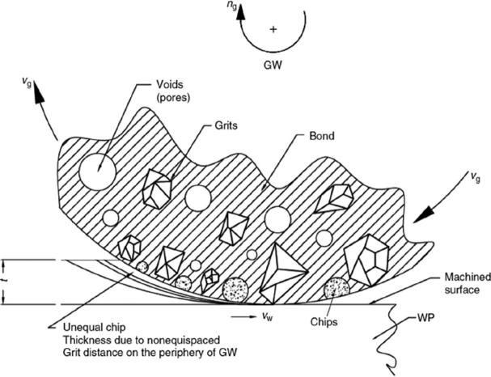
Figure 1: cutting principles and main variables of a Surface

1.1. Grinding Process

System Elements - The system elements consist of inputs, disturbances, productive outputs, and non-productive outputs. The elements of a grinding system are illustrated in figure. Work piece material, Shape, hardness, stiffness, thermal.

1.2. Properties:
- Grinding machine: Type, control system, accuracy, stiffness,
temperature stability, vibrations.

- Kinematics: The geometry and motions governing the engagement
between the grinding wheel and the workpiece.

- Grinding wheel: Abrasive, grain size, bond, structure, hardness, speed, stiffness.

- Dressing conditions: Type of tool, speeds and feeds, cooling, lubrication.

- Grinding fluid: Flow rate, velocity, pressure, physical, chemical properties.

- Atmospheric environment: Temperature,
humidity, and effect on environment.

- Health and safety: Risks to the machine
operators and the public.

- Waste disposal.

- Adopting a ‘dry machining’ strategy will only make sense, if all the cutting processes
in the part’s manufacture can be performed without coolant, Only by utilizing specialized cutting tool
geometries, can ‘dry-machining’.

- Tooling typically having special hard multi-layered, or diamond-like coatings, etc., to isolate heat and create minimal thermal conduction across the tool/chip interface,

- Employing cutting tool materials producing sharp edge geometries – to reduce heat,

- For drilling operations, utilize ‘soft-glide’ coatings –for lubrication, with the necessary and appropriate efficient chip transportation geometries.

Chapter-2

THE TAGUCHI SYSTEM OF QUALITY ENGINEERING:

The major steps of implementing the Taguchi

method are:

  - to identify the factors/interactions,
  - to identify the levels of each factor,
  - to select an appropriate orthogonal array (OA),
  - to assign the factors/interactions to columns of the OA,
  - to conduct the experiment
chapter-3

CONSTRUCTION OFA GRINDING WHEEL:
- In order make the grinding wheel suitable for different work situations, the features such as abrasive, grain size, grade, structure and bonding materials can be varied.
- A grinding wheel consists of an abrasive that does the cutting, and a bond that holds the abrasive particles together.

- Abrasives can be natural or manmade.

  - Natural include:
    - Sand stone

    - Emery

    - Diamond

    - Garnet

    - Quartz

Manmade (1891-time frame most commonly used today)

    - Silicon Carbide

    - Aluminum Oxide

    - Cubic Boron Nitride

3.1. Bonding materials:

  - Vitrified bonds

- Mineral bonds

3.2.Types of grinding wheels:

According. To bonding material:

  - Vitrified grinding wheel

  - Silicate grinding wheel

  - Elastic grinding wheel

  - Resinoid grinding wheel

  - Working grinding wheel

  - Oxy chloride grinding
wheel

3.3.According. to wheels grade:

  - Soft grade wheel

  - Hard grade wheel

Acco.to structure:
- Open structure wheel

- Closed structure wheel

- Acco.to shape of grinding
wheel

Selection of grade depends on hardness of workpiece material, grinding speed, contact area of grinding wheel with the workpiece, capability of grinding machine. Grinding wheels are named as soft, hard or medium hard wheels depending on their grade. Abrasives of hard grinding wheels
3.4 Wheel Forms
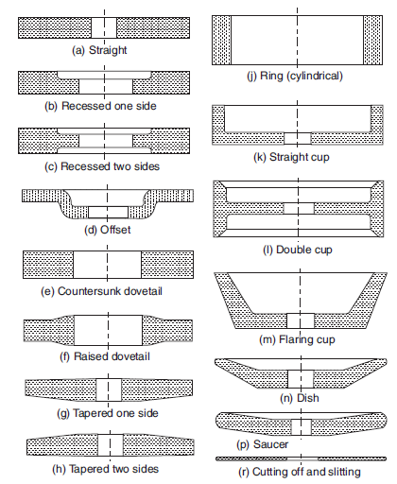
Figure 2: Standard Grinding Wheel Shapes
Different shapes of grinding W heel:
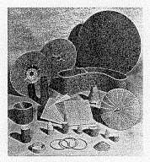
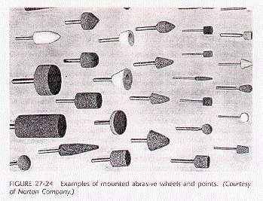
Figure 3: Different Shapes Of Grinding Wheel

3.5. STRUCTURE:
  - This indicates the amount of bond present between the individual abrasive grains, and the closeness of the individual grain to each other. An open structured wheel will cut more freely. That is, it will remove more metal. In a given time and produce less heat.

3.6. BOND:
A bond is an adhesive material used to held abrasive particles together; relatively stable that
constitute a grinding wheel.

3.7. Different types of bonds:

Vitrified bond (V) Shellac bond (E) Resinoid bond (B) Silicate bond (S)
Oxychloride bond (O)

Vitrified Bond:
This bond consists of mixture of clay and water. Clay and abrasives are thoroughly mixed with water to make a uniform mixture. The mixture is molded to shape of a grinding wheel and dried up to take it out from mold. Perfectly shaped wheel is heated in a kiln just like brick making. It this way clay vitrified sand fuses to form a porcelain or glass grains.
High temperature also does annealing of abrasive. This wheel possesses a good strength and porosity to allow high stock removal with coal cutting. Disadvantage of this type of wheel are, it is sensitive for heat, water, oil an
acids. Their impact and bending strengths are also low. This bond is denoted by symbol ‘V’in specification.

Silicate Bond:

Silicate bonds are made by mixing abrasive particles with silicate and soda or water glass. It is molded to required shape, allowed to dried up and then taken out of mold. The raw molded wheel is baked in a furnace at more than 200oCfor several days. These wheel exhibits water proofing properly so these can be used with coolant. These wheels are denoted by ‘S’in specification.

Shellac Bond:

These are prepared by mixing abrasive with shellac than molded by rolling and pressing and then by heating upto150oC for several hours. This bond exhibit greater elasticity than other bonds with appreciable strength. Grinding wheels having shellac bond are recommended for cool cutting on hardened steel and thin sections, finishing of chilled iron, cast iron, steel rolls, hardened steel cams and aluminum pistons. This bond is denoted by ‘E’in specifications.

Resinoid Bond:
These bonds are prepared by mixing abrasives with synthetic resins like Bakelite and red manel and other compounds. Mixture is molded to required shape and baked upto200oC to give a perfect grinding wheel. These wheels have good grinding capacity at higher speed. These are used for precision grinding of cams, rolls and other objects where high precision of surface and dimension influence the performance of operation. A resinoid bond is denoted by the letter ‘B’.

Rubber Bond:
Rubber bonded wheels are made by mixing abrasives with pure rubber and Sulphur. After that the mixture is rolled into sheet and wheels are prepared by punching using die and punch. The wheels are vulcanized by heating then in furnace for short time. Rubber bonded wheels are more resilient and have larger abrasive density. These are used for precision grinding and good surface finish. Rubber bond is also preferred for making thin wheels with good strength and toughness. The associated disadvantage with rubber bond is, these are lesser heat resistant. A rubber wheel bonded wheel is denoted by the letter ‘R’.

Oxychloride Bond:
These bonds are processed by mixing abrasives with oxides and chlorides of magnesium. The mixture is molded and baked in a furnace to give shape of a grinding wheel. These grinding wheels are used for disc grinding operations. An oxychloride bonded wheel is specified the letter ‘O’.
Chapter-4

SURFACE GRINDING OPERATIONS:

- Rough grinding

- Precision grinding

- Surface grinding

- Centerless grinding

- Form grinding & Profile grinding

- Plunge cut grinding
Chapter-5

GENERALSAFETY

    - Keep the floor and gangways clean and clear.

    - Don’t touch or handle any equipment/machine unless
authorized to do so.

    - Don’t walk under suspended.

    - Use the correct tools for the job.

    - Keep the tools at their proper palace.

    - Wipe out split oil immediately.

    - Ensure adequate light in the workshop.

6.Grinding Wheel Operating Procedures
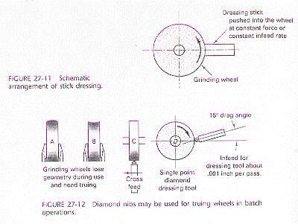

Figure 4: Schematic Arrangement of stick dressing
,

Wheel Classification:
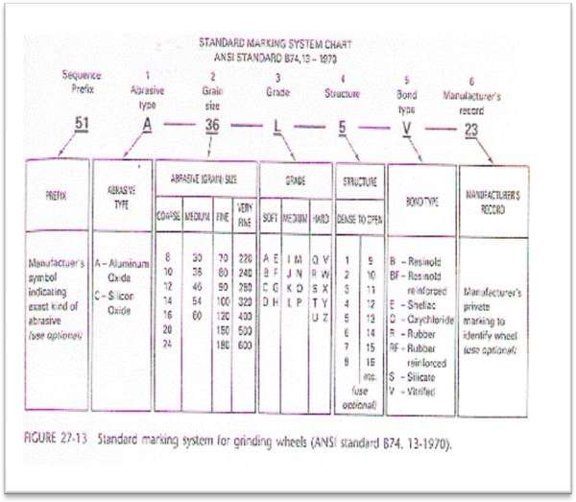
Figure 5: Standard Marking System Chart
Chapter-7

Nomenclature of grinding wheel

- Manufacturer symbol

- Types of abrasive

- Grain size

- Grade

- Structure

- Types of bonds

- Manufacturer Mark

Chapter-8

Analysis of grinding wheel with different speed

peripherical speed of grinding wheel:
When the rotation speed decreases, the grinding wheel behaves as if it were softer, thus improving its grinding capacity. As a general guide, with every 5-8 mt/sec reduction in peripheral speed the grinding wheel loses approximately 1 degree of hardness. In contrast, if we need the grinding wheel to retain its profile or to produce a better finish (i.e. behave as if it were harder) the peripheral speed should be increased. Within reason, however: a grinding wheel that turns too slowly tends to lose its grains before the abrasive granules have the chance to work. Conversely, when increasing the speed, the limit is the maximum allowable speed indicated on the label of the grinding wheel, which absolutely must not be exceeded to avoid the risk of the tool exploding. Normally the recommended peripheral speed is slightly lower than the maximum indicated on the grinding wheel.

speed of workpiece:
When the speed of the workpiece is reduced, each granule has to remove a larger quantity of material and is therefore subjected to greater pressure, meaning that the grinding wheel self-dresses more easily, and so behaving as if it were softer. The desired effect is not always achieved, however. Often on grinding wheels of medium-to-high hardness the greater stress to which they are subjected cancels out the self-dressing action of this expedient. As a rule, the speed of the workpiece can range between 10 and
20 meters per minute. For surfaces grinding this value corresponds to the table speed.

Chapter-9

PARAMETERS OF GRINDING OPERATION:

9.1Cutting Speed:

Cutting speed is grinding wheel is the relative peripheral speed of the wheel with respect to the workpiece. It is expressed in meter per minute (mpm) or meter per second (mps). The cutting speed of grinding wheel can be calculated as mpm
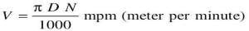
where, D is diameter of grinding wheel in mm. N are the number of revolutions of grinding wheel if N is expressed in number of revolutions per minute, V will be in mpm, if N is expressed in number of revolutions per second, V will be in mps.

9.2Feed Rate:
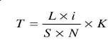
Feed rate is a significant parameter in case of cylindrical grinding and surface grinding. Feed rate is defined as longitudinal movement of the workpiece relative to axis of grinding wheel per revolution of grinding wheel. Maximum feed rate should be upto0.9 time of face width of grinding wheel for rough grinding and upto0.6 times of face width of grinding wheel for finish grinding. Feed cannot be equal to or more than the width of grinding wheel. Feed is used to calculate the total grinding time as given below.

where T is the grinding time (min) L is the required longitudinal travel in mm. i is the number of passes required to cover whole width, S is the longitudinal feed rate (mm/rev.). N is the rpm and K is the coefficient depending on the specified grade of accuracy and class of surface finish for rough grinding K = 1 to 1.2 and for finish grinding K = 1.3 to 1.5.

9.3Depth of Cut:

Depth of cut is the thickness of the layer of the metal removal in one
pass. It is measured in mm. normally depth of cut is kept ranging 0.005 to
0.04 mm. smaller depth of cuts are set for finish and precision grinding. The table given below shows recommended bonds and cutting speed for type of a workpiece.

Table 1:Type of Grinding according to type of workpiece, Bond and Cutting Speed
TYPE OF WORKPICE | BOND | CUTTING SPEED
Tool Steel | Vitrified | 15 TO 25 | PRECISION GRINDING
High Speed Steel | Vitrified | 15 TO 25
Cemented Carbide | Resin or Rubber | 15 TO 25
CAST IRON | Resin or Rubber or  Vitrified | UPTO 30 | ROUGH GRINDING
STEEL |  | UPTO 25
Bronze |  | UPTO 20
Soft Iron |  | UPTO 20

Chapter-10

GRINDING FLUIDS:

Application of grinding fluids has been found to be effective in reducing the adverse thermal effects and high work surface temperature. All cutting fluids can be used as coolant in grinding operations and so these can also be named as grinding fluids.

Normally grinding fluids remove heat from grinding zone and wash the clips away.
Generally, two types of grinding fluids are used:
(a)Water based fluids, and
(b) Oil based fluids.

Water based fluids remove heat from grinding zone but these do not provide any lubrication to the grinding zone. However, oil-based fluids provide lubrication properties also. Heat removing capability of oil base fluid is more due to their high specific heat. Examples of water-based fluids are dissolved chemicals into water like sulfur chlorine, phosphorus, etc. Examples of oil-based fluids are oils originated from petroleum, animals and vegetables. They can be emulsified oils suspended in water in the form of droplets. Cutting fluids can be recycled in flow after filtering them by separating out chips and dirt.

Chapter-11

DEFECTS AND REMEDIES IN GRINDING:
Major and inevitable defects in grinding are glazing of grinding wheels. Its remedy will be discussed later. After the continuous use grinding wheel becomes dull or glazed. Glazing of the wheel is a condition in which the face or cutting edge acquires a glass like appearance. That is, the cutting points of the abrasives have become dull and worn down to bond. Glazing makes the grinding face of the wheel smoother and that stops the process of grinding. Sometimes grinding wheel is left ‘loaded’. In this situation its cutting face is found being adhering with chips of metal. The opening and pores of the wheel face are found filled with workpiece material particles, preventing the grinding action. Loading takes place while grinding workpiece of softer material.

Dressing:

The remedies of glazing and loading is dressing of grinding wheels.

Dressing removes the loading and breaks away the glazed surface so that sharp abrasive particles can be formed again ready for grinding. Different type of dressing operations are done on a grinding wheel. One of them is the dressing with the help of star dresser. It consists of a number of hardened steel wheels with sharp points on their periphery.

The Tool is Held against the face of revolving wheel and moved across the face to dress the whole surface. Another type of wheel dresser consists of a steel tube filled with a bonded abrasive. The end of the tube is held against the wheel and moved across the face.

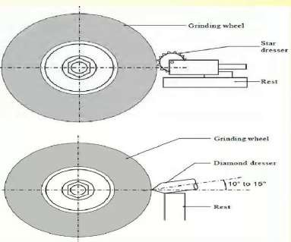

Figure 6: Dressing of Grinding Wheel

Truing: Truing is the process of restoring the shape of grinding wheel when it becomes w orn and break away at different points. Truing makes the wheel true and concentric with the bore.

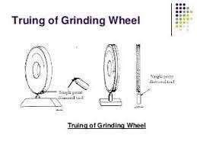

Figure 7: Truing of Grinding Wheel

Chapter-12

BALANCING OF GRINDING WHEEL:
Due to continuous used a grinding wheel may become out of balance. It cannot be balanced either by truing or dressing. Here it is important to explain the meaning of a balanced wheel. It is the coincidence of Centre of mass of wheel with it axis of rotation. Wheels which are out of balance produce poor quality of surface and put undue strains on the grinding machine. Balancing of wheel is normally done at the time of its mounting on the grinding machine with the help of moving weights around a recessed flange.

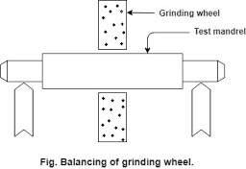
Figure 8: Balancing of Grinding wheel

INFLUENCE OF OPERATING PARAMETERS ON GRINDING WHEEL BEHAVIOUR

Table 2: Influence of operating parameters on grinding wheel
PARAMETERS |  | HARDNESS | CAP.ASP. | FINISH
peripheral speed of wheel | >  < | >  < | <  > | >  <
feed rate | >  < | <  > | >  < | <  >
depth of cut per pass | >  < | <  < | >  < | <  >
It is clear that by varying the operating parameters appropriately it is possible to use the same grinding wheel for more than one kind of machining process. Of course, when large numbers of pieces need to be produced it is always advisable to use a dedicated grinding wheel.

Block Diagram
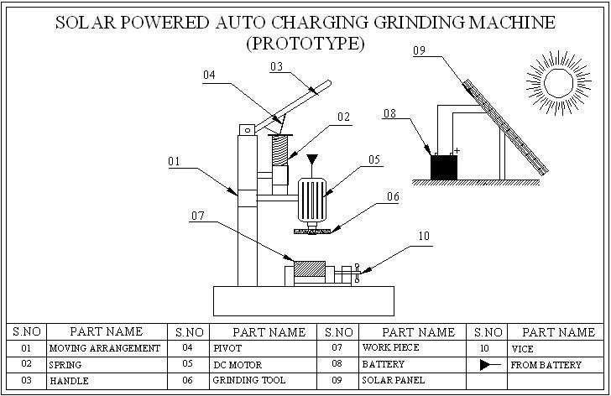
Figure 9: Block Diagram of grinding wheel

Chapter-13

BLOCK DIAGRAM DESCRIPTION:

VICE

It is a device consisting of two parallel jaws for holding a work piece; one of the jaws is fixed and the other movable by a screw, a lever, or a cam. When used for holding a work piece during hand operations, such as filing, hammering, or sawing, the vise may be permanently bolted to a bench. In vises designed to hold metallic work pieces.

The active faces of the jaws are hardened steel plates, often removable, with serrations that grip the work piece to prevent damage to soft parts; the permanent jaws can be covered with temporary jaws made from sheet copper or leather. Pipe vises have double V-shaped jaws that grip in four places instead of only two. Woodworking vises have smooth jaws, often of wood, and rely on friction alone rather than on serrations.

SPRING

The automobile chassis is mounted on the axles not direct but through some form of springs. This is done to isolate the vehicle body from the road shocks which may be in the form of bounce, pitch, roll or sway. These tendencies give rise to an uncomfortable ride and also cause additional stress in the automobile frame and body. All the parts which perform the function of isolating the automobile from the road shocks are collectively.

CAM PLATE
The reason the cam acts as a lever is because the hole is not directly in the center, therefore moving the cam rather than just spinning. On the other hand, some cams are made with a hole exactly in the Centre and their sides act as cams to move the levers touching them to move up and down or to go back and forth.
A cam plate is a projecting part of a rotating wheel or shaft that strikes a
lever at one or more points on its circular path. The cam plate can be a simple

tooth, as is used to deliver pulses of power to a steam hammer, for example, or an eccentric disc or other shape that produces a smooth reciprocating (back and forth) motion in the follower which is a lever making contact with the cam.

BEARING
A bearing is a device to permit constrained relative motion between two parts, typically rotation or linear movement. Bearings may be classified broadly according to the motions they allow and according to their principle of operation. Low friction bearings are often important for efficiency, to reduce wear and to facilitate high speeds. Essentially, a bearing can reduce friction by virtue of its shape, by its material, or by introducing and containing a fluid between surfaces. By shape, gains advantage usually by using spheres or rollers. By material, exploits the nature of the bearing material used. The Sliding bearings, usually called bushes bushings journal bearings sleeve bearings rifle bearings or plain bearings. Rolling- element bearings such as ball bearings and roller bearings.
The Jewel with bearings, in which the load is carried by rolling the axle slightly off-center. fluid bearings, in which the load is carried by a gas or liquid magnetic bearings, in which the load is carried by a magnetic field Flexure bearing, in which the motion is supported by a load element which bends. Bearings vary greatly over the forces and speeds that they can support. Forces can be radial, axial (thrust bearings) or moments perpendicular to the main axis.

A linear-motion bearing or linear slide is a bearing designed to provide free motion in one dimension. There are many different types of linear motion bearings and this family of products is generally broken down into two sub- categories: rolling-element and plane.

Motorized linear slides such as machine slides, roller tables and some dovetail slides are bearings moved by drive mechanisms. Not all linear slides are motorized and non-motorized dovetail slides, ball bearing slides and roller slides provide low-friction linear movement for equipment powered by inertia or by hand.

All linear slides provide linear motion based on bearings, whether they are ball bearings, dovetail bearings or linear bearings. Linear stages, machine slides and other advanced slides use linear motion bearings to provide movement.

Friction
Reducing friction in bearings is often important for efficiency, to reduce wear and to facilitate extended use at high speeds and to avoid overheating and premature failure of the bearing. Essentially, a bearing can reduce friction by virtue of its shape, by its material, or by introducing and containing a fluid between surfaces or by separating the surfaces with an electromagnetic field. By shape, gains advantage usually by using spheres or rollers, or by forming flexure bearings. By material, exploits the nature of the bearing material used. (An example would be using plastics that have low surface friction.)
By fluid, exploits the low viscosity of a layer of fluid, such as a lubricant or as a pressurized medium to keep the two solid parts from touching, or by reducing the normal force between them. By fields, exploits electromagnetic fields, such as magnetic fields, to keep solid parts from touching. Combinations of these can even be employed within the same bearing. An example of this is where the cage is made of plastic, and it separates the rollers/balls, which reduce friction by their shape and finish.

Stiffness
A second source of motion is elasticity in the bearing itself. For example, the balls in a ball bearing are like stiff rubber, and under load deform from round to a slightly flattened shape. The race is also elastic and develops a slight dent where the ball presses on it.
The stiffness of a bearing is how the distance between the parts which are separated by the bearing varies with applied load. With rolling element bearings this is due to the strain of the ball and race. With fluid bearings it is due to how the pressure of the fluid varies with the gap (when correctly loaded, fluid bearings are typically stiffer than rolling element bearings).

Chapter-14

Working Principle:

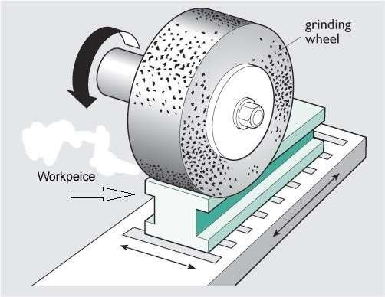
This concept contains simple arrangements. It consists of grinding wheel, solar panel, battery, motor etc. The grinding wheel is fixed on a motor shaft. The battery, solar panel and grinding wheel arrangements are mounted on assembly box. The solar panel generates the power supply from direct sunlight. Then the generated energy is stored in the batteries. The store energy in the battery is used to run the motor. The grinding wheels are fixed at the motor shaft. The motor shaft rotates the grinding wheel. A handle is placed with spring arrangement to move the grinding wheel up and down. In idle time the motor is switch off by the manual process.
Figure 10: principle of Grinding

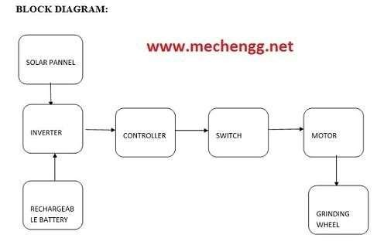
METHODOLGY
Figure 11: Block Diagram

15.Advantages:

- Cheapest method

- Usage of solar
energy

- Low power consumption

- Available source

16.Disadvantages:

- Solar energy is only available in day time.

17.Applications:

- Used small scale industries

- Pattern shops

- Lathe workshops for make surface finish in
specimens

Chapter-18

Conclusion
The solar grinding machine is designed, fabricated and tested. This machine does not employees any use of power equipment’s such as DC motors and it is fully human operated. The use of this machine makes the grinding process faster hence reduce most of the time and labor required to operate the machine is also less. This machine is helpful for small as well as big firms. This human powered machine will help to improve an economical condition. This is new type of machine which is different to the other grinding machine which are used for grinding purpose till now.

19.Scope for future work:
      - The objective of this project is to design and fabricate a low cost multi crop cutting machine based on the need of farmers.
      - To minimize time of harvesting.
      - To minimize the human effort.

20.References:
[1] Machine tools and tool design by P. C. Charama published by S. Chand and company.
[2] http://www.ssiproject.com/mechanical_projects/ solar powered auto charging grinding machine

